**Curate a comparison documentation btw HTTP1 and HTTP2**

|  |  |  |
| --- | --- | --- |
|  | HTTP1 | HTTP2 |
| Connection type | Follows synchronous request-response connection btw the client and server | Follows asynchronous request- response connection btw client and server with multiplexing & pipelining concept |
| Implementation feedback | Once a request is sent, the server connection is stuck until all the responses are received by the client  **Sample**- Loading of requested web page-> HTML -> CSS -> JS -> Media *files are loaded one after the other* | Once a request is sent, the server throws back all the responses requires for the client in random orders at the same time  **Sample**- Web page load request is made, the HTML, JS, CSS, Media *files are all sent to the client at any order at the same time* |
| Scope of Improvement | One client can have multiple connections to the server for a single request. But the costing and the network trafficking will lead to complications | Bandwidth of the TCP/IP connection is the only constraint for slow transfer of data.  **Sample**- If the TCP connection has bandwidth for only JS &HTML, the CSS & Media files are sent in the second set |

**Reference media file**

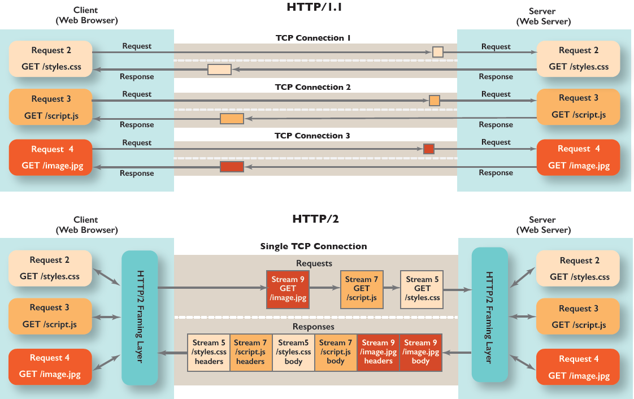

*Source-* [*https://freecontent.manning.com/animation-http-1-1-vs-http-2-vs-http-2-with-push/*](https://freecontent.manning.com/animation-http-1-1-vs-http-2-vs-http-2-with-push/)